**Develop a web application using Node RED to view data separately**

|  |  |
| --- | --- |
| DATE | 17 november 2022 |
| TEAM ID | PNT2022TMID20858 |
| PROJECT NAME | SmartFarmer - IoT Enabled Smart Farming Application |

Step 1:

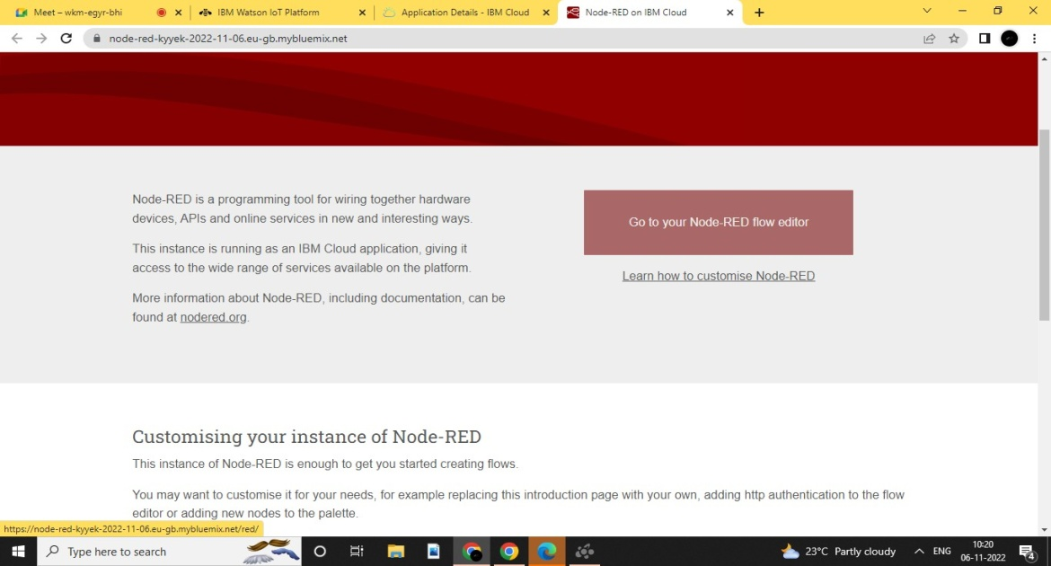

Step 2:

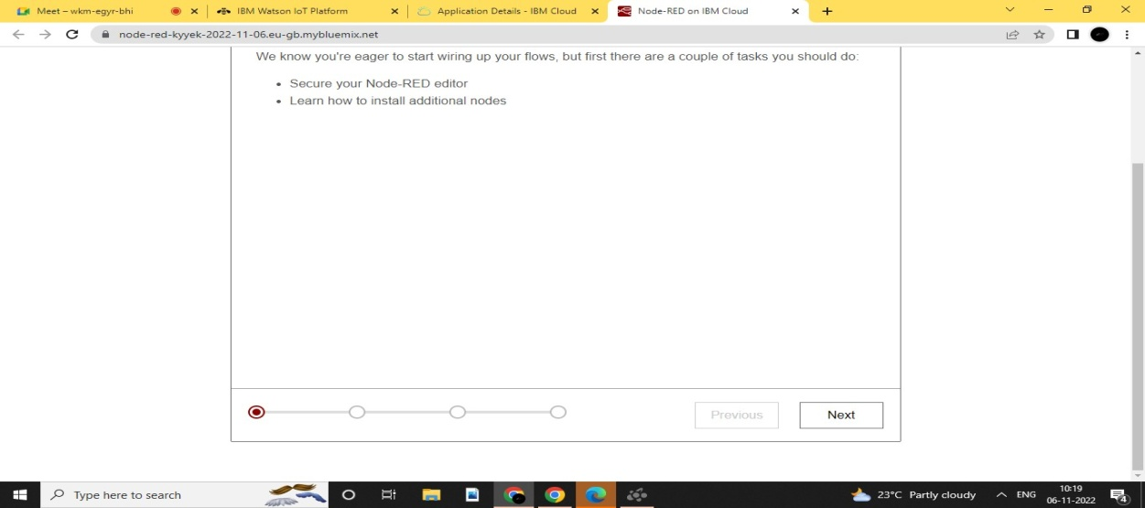

Step 3:

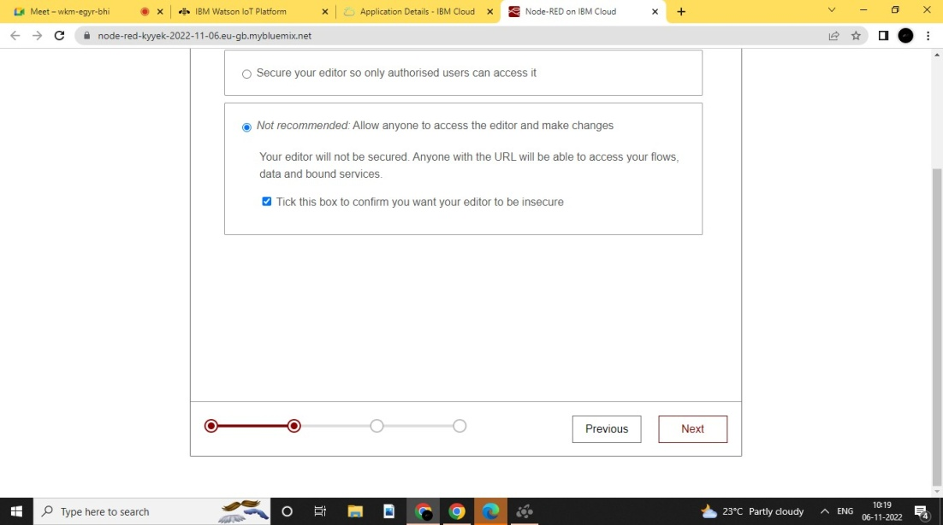

Step 4:

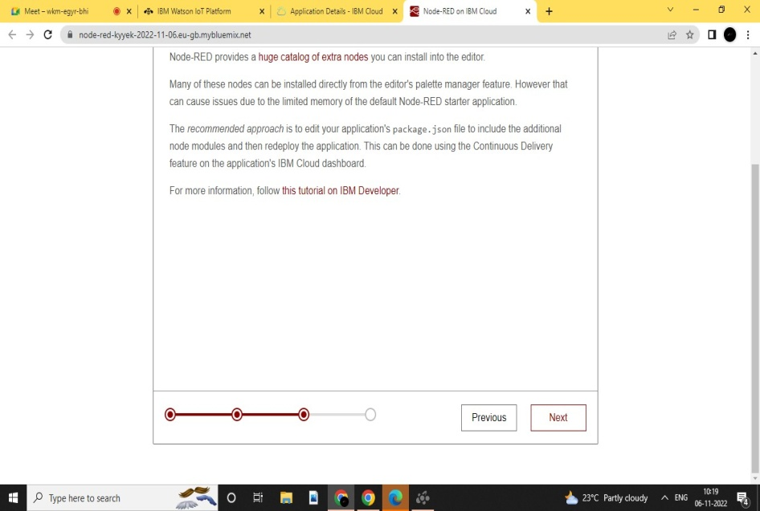

Step 5:

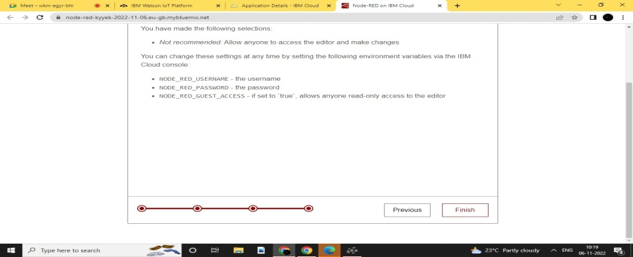

Step 6:

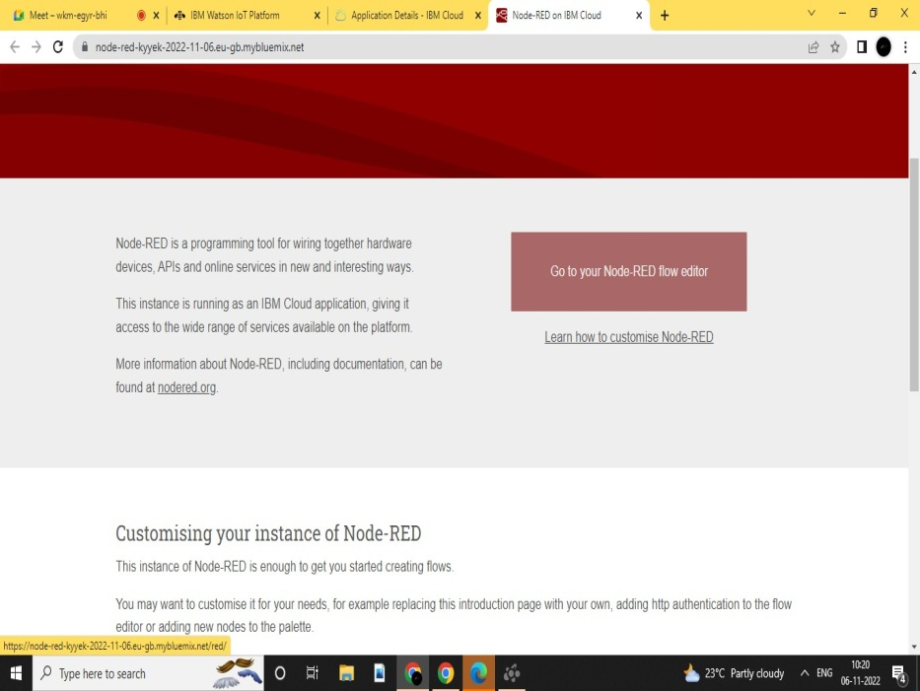

Step 7:

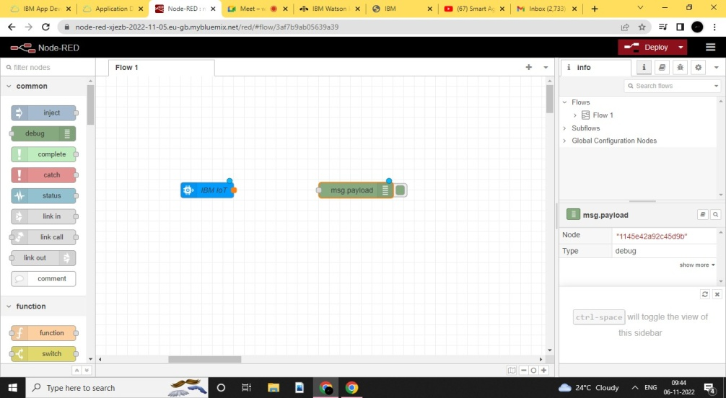

Step 8:

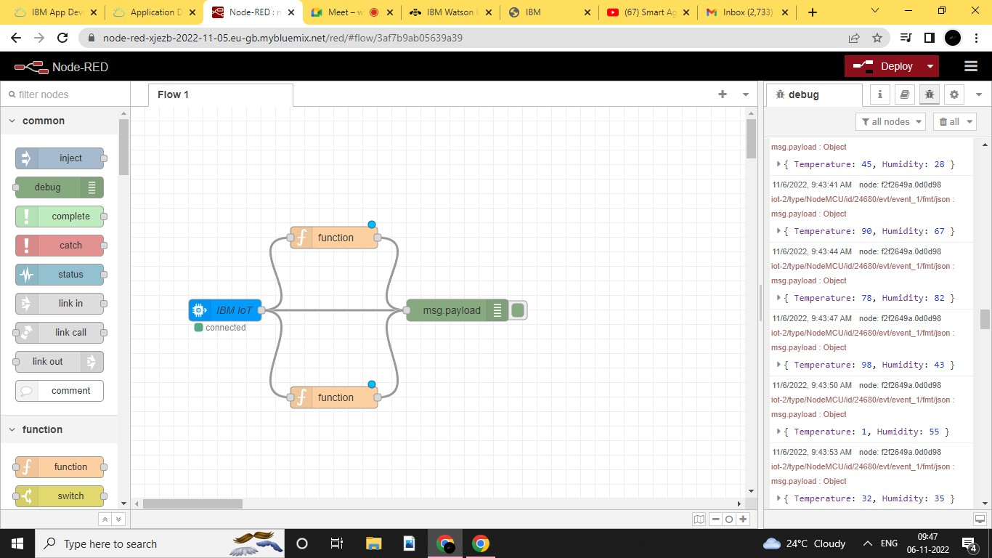

Step 9:

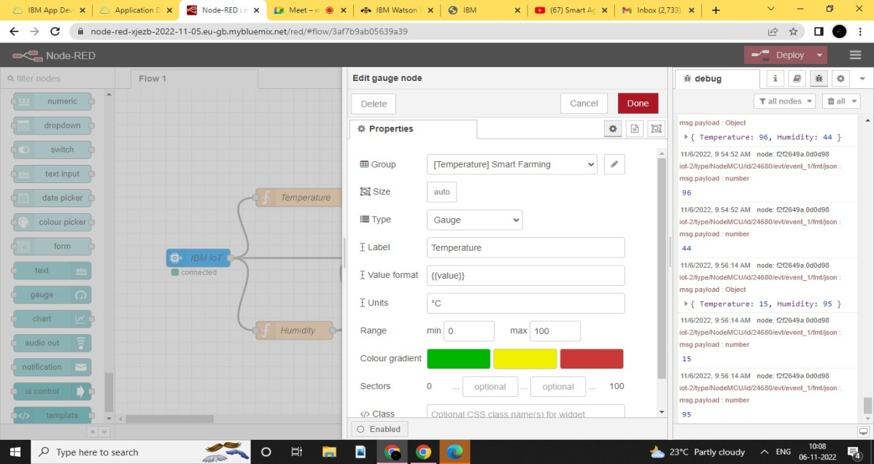

Step 10:

